BRIEF | Elev8
Dear Partner,
This series is designed to introduce Elev8 to a broader audience through short, clear and trust-oriented content. Below, you’ll find all the details and guidelines to help you craft impactful and engaging content for your audience.
____________________
About the Campaign
Introduce Elev8 to a wider audience through a natural, low-pressure narrative — without aggressive sales language. The aim is to build brand trust by showing the product as a genuine part of the influencer's everyday experience, not as an advertised item. At the center of the story is the moment the creator uses the AI pattern recognition feature in the terminal, which uses AI to spot patterns in the chart, so they can be even more confident in their decisions.
Content Approach (Soft Sell):
- Product is included organically into context — presented as personal experience, not a pitch
- No direct CTAs like "open an account/sign up now" — focus on demonstration over persuasion
- Conversational, authentic tone — as if sharing a discovery with a friend
- Complex details (trading mechanics, technical aspects) stay in the background — focus on ease and the emotion of discovery
- There is no need to include a link to the application or website
Key Messaging Pillars (delivered subtly, through personal experience):
- At the center of the story is the moment the creator discovers the Space feed and uses other traders' ideas as a source of inspiration for their own decisions.
- Space as a source of ideas (primary focus) — show through an actual scroll of the feed: the creator browses other traders' ideas, pauses on one that matches something they'd already been noticing in the market ("oh, I was literally just thinking about that"). Don't explain what Space is — show how it's used
- Transparency — through real interface screenshots, not stated outright
- User-friendly experience — "here's how I find an idea and check the details in a couple of clicks" — without explaining why it's convenient
- Modern trading ecosystem — through visuals and atmosphere (clean interface, modern UX of the terminal) — not through text/voiceover
Format:
Simple, clear storytelling or demo moment from everyday life — the creator opens the app not "for the ad," but because they "want to see what the AI's picked up on the chart right now." AI pattern recognition is part of the content, not its subject; no trading lesson, just a natural gesture of opening the terminal and a light reaction to the pattern found.
Product: Elev8
Please, use the correct name Elev8 (read like ‘elevate’)
Disclaimer:
Please, add the disclaimer to your video description
Trading is risky. Trade responsibly.
Make sure you have downloaded the latest application

Call-to-Action (CTA) in the end of the videos:
Use soft selling CTA only:
- Explore Elev8 yourself
- Learn more
- If you’re curious, check the details in the description
Technical Requirements:
- Platform: Instagram, TikTok, YouTube (depending on availability).
- Video Length: Max 2 minutes.
- Format: Use 1:1, 16:9, or 9:16 formats.
- App Demo: Demonstrate key app features
- The video and the audio must be of a high quality.
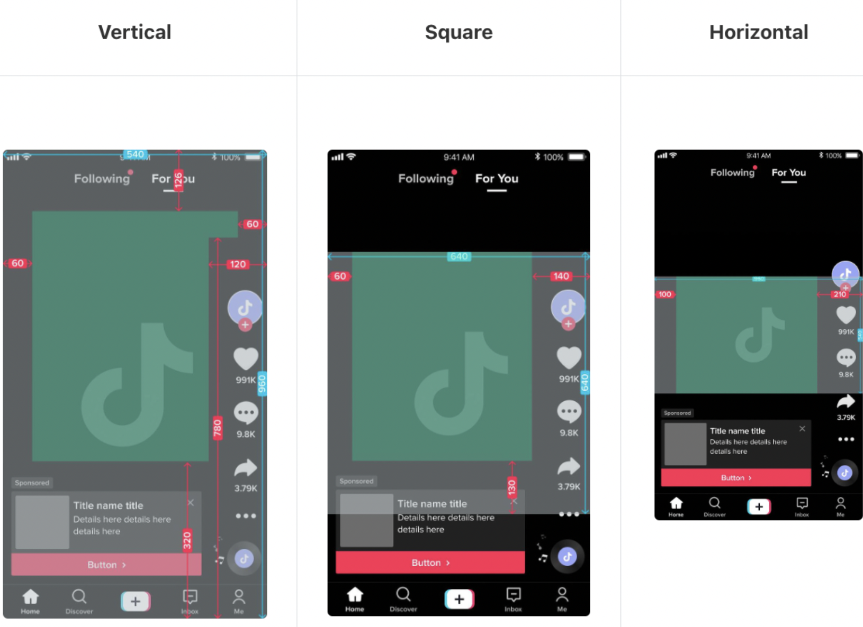
- Don’t place the text outside of the safe zones.

✅ Do:
- Highlight transparency, trust, and a smooth user experience
- Keep messaging simple and reassuring.
- Use positive, confident language.
- Encourage curiosity about the platform and its features.
❌ Don’t:
- Promising quick or guaranteed earnings
- Using phrases such as easy money or no risk
- Comparing Elev8 with other brokers
- Making the content overly aggressive or sales-focused
____________________
Please feel free to reach out if you have any questions.

